Extended Abstract Template for Creations de UiTM: International Mega Innovation Carnival 2023

*¹First Author (Full Name), ^{1,2}Second Author (Full Name), ³Third Author (Full Name)

^{1,2}Authors’ Department, Institute, City, Country

³Centre of Foundation Studies, Universiti Teknologi MARA, Cawangan Selangor, Kampus Dengkil, 43800 Dengkil, Selangor, Malaysia

*E-mail: corresponding author’s email address

ABSTRACT

All extended abstracts must be accompanied by an abstract of not more than 200 words and written in English. Page format should be A4 page-sized (21 x 29.7 cm or 8 x 11 in) with margins 2.5 cm (0.98 in) wide from the right, left, top, and bottom. Use 12-point Times New Roman font, single line spacing, and justified alignment for the text. The abstract summarises the majority of aspects of innovation. It allows readers to glance through the contents of innovation rapidly. The abstract should contain a concise description of the innovation that includes (i) problem statement(s) or objective(s), (ii) innovation development, (iii) commercial potential, and (iv) a brief conclusion. Please include keywords as shown below and exclude figures, tables, or citations in the abstract.

Keywords: Keyword 1; keyword 2; keyword 3 (3-5 keywords only)

INTRODUCTION

This template demonstrates the preparation of extended abstract for Creations de UiTM 2023 e-proceeding. Please read and adhere to the formatting instructions. The easiest way to do this is to replace the words written in red fonts with your own.

Authors are requested to submit the extended abstract of 3 to 5 pages in length in electronic form of MS Word via our online registration webpage. Page format should be A4 page-sized (21 x 29.7 cm or 8 x 11 inches) with margins 2.5 cm (0.98 inches) wide from the right, left, top, and bottom. Use 12-point Times New Roman font, single line spacing, and justified alignment. The extended abstract must consist of the Section Headings (Introduction, Innovation Development, Commercial Potential, and Conclusion). Subsections (Second-Level Headings) also can be included. Please indent the text paragraphs, except the first paragraph in Section Headings and Second-Level Headings.

In the Introduction, please ensure the problem statement(s) is/are well defined and lead to the innovation of the product specified. State the objective(s) clearly. Explain the innovation motivation.

All references should be cited in the text by square brackets [1]. If more than one reference is cited at a time, put them in one set of square brackets [1,2]. List and number all references accordingly in the extended abstract under the Section Heading, References [1-3].

INNOVATION DEVELOPMENT

Describe the innovation development in sufficient detail with evidence to support the originality and novelty of the product. Illustrate a complete prototype/system/sample with images/figures complete with labels. Highlight the inventive features of the product.

COMMERCIAL POTENTIAL

Discuss the relevance of the invention in addressing the related problem(s) and how it contributes to new knowledge, technology, environment, or society. Explain the market needs and market potential. Interpret how the product provides the solution to the user’s needs and its marketability. Highlight the proposed selling price and expected profit margin if relevant. Provide evidence of sales records for the marketed product. Include proof of the related published work and related Intellectual Property Recognition (IPR), if any.

Subsections/Second Level Headings

Bold the Subsections/Second-Level Headings (if there are any) and capitalize each word.

Figures

Figures can be included in your extended abstract and referred to in the text as Figure 1, Figure 2, and followed by others. All the figures should be centred, with the figure header placed under the image.

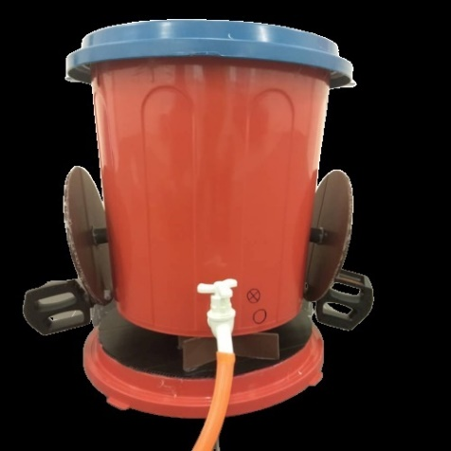

Figure 1: Innovation prototype

Tables

All tables should be inserted (see sample below) and labelled Table 1, and Table 2, followed by others. The header for each table should be centred and placed at the top.

Table 1: Example of table

Contents of Table

Equations

Equations should be labelled as follows, (1), (2). Include a space above and below each equation to segregate it from the text. The equations must be numbered sequentially, with the numbers placed in parentheses at the right-hand edge of the text.

c² = a² + b² (1)

Special Symbols

Write symbols such as α, γ, μ, Ω, (), ≥, ±, ●, Γ, or {110} in Times New Roman or Arial font, and these include the ones listed in the figures and tables.

CONCLUSION

Conclusions should answer the objective(s) proposed. Authors should include future development, recommendation, or improvisation planning.

ACKNOWLEDGEMENT

The authors can include an acknowledgment to express their appreciation for the support of the sponsors. Include details such as research grant, individual(s), or name(s) of organization/institution.

REFERENCES

List the references according to the latest APA style. The minimum number of references list is eight the maximum number is fifteen.

[1] Author, A., & Author, B. (year). Title of article. Journal Title, Volume (Issue), page range. DOI.
[2] Schmidt, F. L., & Oh, I.-S. (2016). The crisis of confidence in research findings in psychology: Is lack of replication the real problem? Or is it something else? Archives of Scientific Psychology, 4(1), 32–37. https://doi.org/10.1037/arc0000029.
[3] Author, A., & Author, B. (year). Title of book. DOI/URL/Publisher Name.
[4] Brown, B. (2010). The gifts of imperfection: Let go of who you think you're supposed to be and embrace who you are. Hazelden.
[5] Author. (year). Title of page. Retrieved Date, from http://xxxxxxx.
[6] American Psychological Association. (n.d.). Divisions. Retrieved October 28, 2018, from http://www.apa.org/about/division.
[7] Author, A., & Author, B. (year). Title of chapter. In E. Editor & A. Editor (Eds.), Title of book (pp. xx-xx). DOI/URL/Publisher Name.
[8] Singh, A. A., Hwang, S. J., Chang, S. C., & White, B. (2017). Affirmative counselling with trans/gender-variant people of color. In A. Singh & L. M. Dickey (Eds.), Affirmative counselling and psychological practice with transgender and gender nonconforming clients (pp. 41–68). https://doi.org/10.1037/14957-003.

